C5_T3_Lessons Learned

Overview

The scope of this project is to employ sentiment analysis on web data related to smart phone devices. This analysis would be used to ascertain which smart phone devices would be appropriate to focus on for the sake of developing medical apps.

In other words, by ascertaining which smart phone devices are generally favored, this could help inform decisions regarding purchase costs and training. That is, by having a uniform suite of smart phone devices, this could help to reduce costs as phone-related costs are standardized. As for training, this uniformity could help streamline training processes for the medical apps as every aid worker would be using the same smart phone devices.

A necessary component of this project is to obtain web data so that is might be analyzed. This technically-involved aspect of the project was conducted through Amazon Web Services (AWS).

Methodologies

Without going into too much technical depth, the broad process for this project were as followed:

1. Carefully read through any relevant documentation and client requirements in order to understand the project scope and prepare a technical plan for the sentiment analysis.
2. Obtain data about smart phones via webscraping. Webscraping is the process of gathering information from websites. This was done using AWS.
3. Conduct some preliminary statistical analysis on different versions of the smart phone data, such as the distribution of iphone and galaxy sentiment.
4. Test models on different versions of the smart phone data.
5. Evaluate the accuracy performance of different models, with different versions of the smart phone data, in order to ascertain the best performing model.
6. Apply the best performing model to the complete dataset, which refers to step 1.
7. Summarize key findings in the form of a final document.

Findings

As the name suggests, sentiment analysis is about ascertaining the range of sentiments for some focus of study. In the case of this project, my analysis involved ascertaining the possible sentiments for iPhones and Galaxy phones. Those sentiments were as followed: 0 (Unclear), 1 (Very Negative), 2 (Somewhat Negative), 3 (Neutral), 4 (Somewhat Positive) and 5 (Very Positive). Regardless of the techniques used, the sentiment outcomes between these two phones were similar. Attached below are graphs that illustrate the sentiment distributions between iPhones and Galaxy phones.

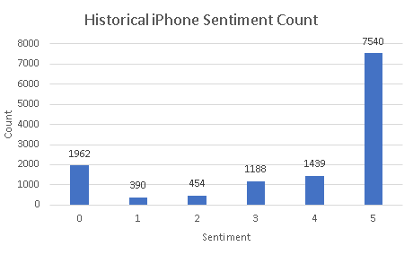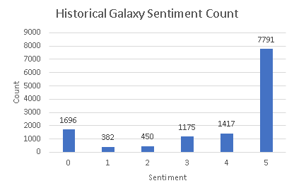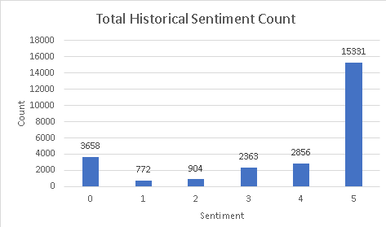

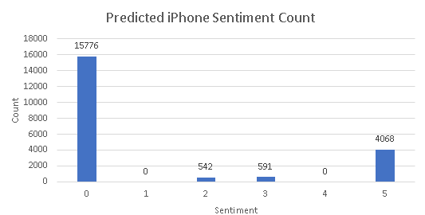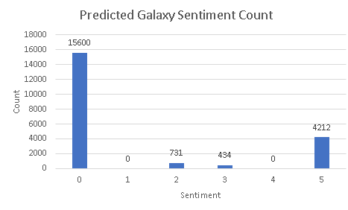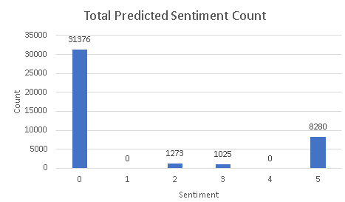

As we can clearly see when comparing between the actual sentiments (the “historical” graphs) and the predicted sentiments (the “predicted” graphs), the most surprising conclusion of this analysis is that determining clear sentiment outcomes is quite difficult. **That being said, as to the question of which phone should be chosen --- the answer is the Galaxy phone.** This is because that phone has more “Very Positive” reviews than the iPhone.

Confidence

In this section of the report, a table is included that indicates the performance metrics, by measure of Accuracy scores and Kappa scores, for each dataset used and for each model created. For simplicity’s sake, the best performing models were indicated by bold and highlight. Such models were used in the creation of the “predicted” graphs as mentioned in the previous section.

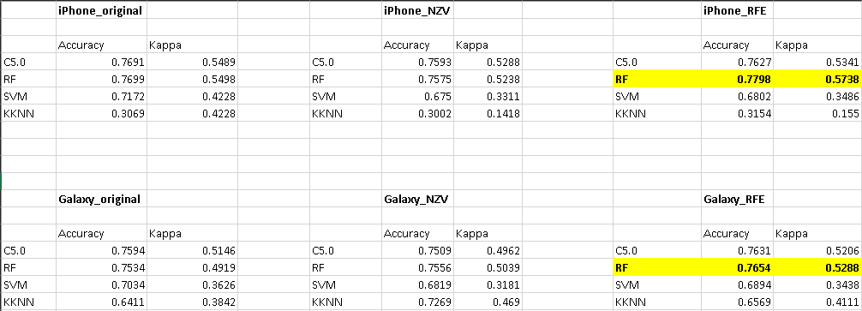

Implications

Unfortunately, a major consequence of this analysis is that sentiment analysis proved to yield inconclusive results as to the core question of the client. Further research and work will be needed to yield more certain results. Two important considerations are needed so as to inform future projects regarding sentiment analysis:

1. How is sentiment being measured and calculated?
2. How reconcilable are the differences in sentiment prediction between data annotation (human-entered labeling) versus automated annotation (applying machine learning tools for labeling)

These two considerations are important as they will impact business expectations and the overall design of the analysis process. Such considerations would inform efforts of data collection, data processing, and model development and evaluation. More specifically, the code responsible for ascertaining sentiment (Wrapper.py script) should be modified so as to be more discerning of more sentiment-based words, for the sake of reducing the amount of “Unclear sentiment” (0) outcomes.

While it is unsatisfactory that a definitive conclusion could not be researched, between whether to choose iPhones or Galaxies, it appears relatively clear that – given sentiment analysis alone, that either phone device could be a viable candidate for use for the client’s needs. That being said, given the findings of this analysis, I would still recommend that Galaxies be chosen for use.